**Sky High** We have a competitive event in the game that grants rewards to the first player who finishes 5 levels before the others. The popup below appears when the event is “on” and we're unhappy with the text:

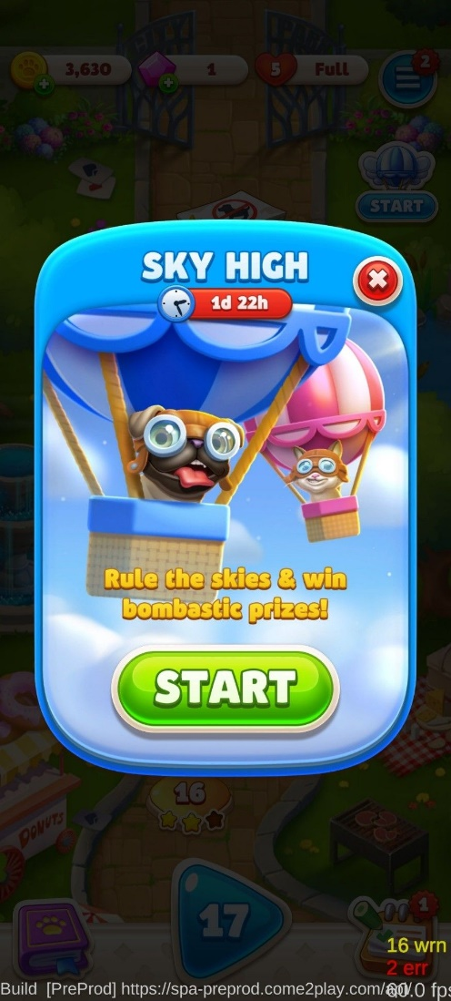 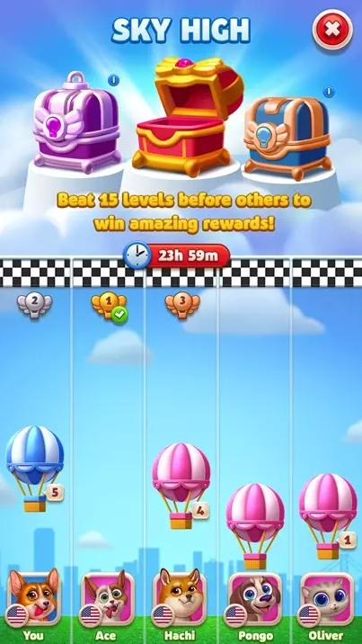

The screen on the right is how the event looks like after clicking “Start”.

**Tutorial texts needed**:

1. We have a hurdle in the game which is a card that counts-down moves to the user. Once the countdown reaches “0”, the card explodes, and the user loses the game. The card can be disarmed by placing a matching card on it, or by moving it to the foundation. We need a name for this card and a tutorial text that will explain this logic to the players (current animation is asking the user to tap a matching card so they will see how the explosive card is disarmed):

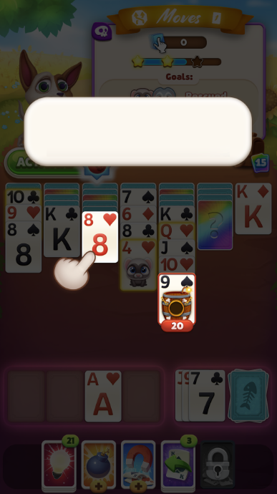

**Monetization:**

**Solitaire Challenge Event–**

We have a challenge in the game which players progress on different path of levels and in different game modes. The challenge can be played only with unique tickets that can be acquired from Surprise Cards of regular map levels, buying them at the store or progress in the challenge itself. The challenge duration is for 3 days.

This challenge will be in Blitz Mode:

Blitz Mode:

players race against the clock and need to win a level before time runs out.

Rewards:

The challenge has milestones of prizes, every X wins the player gets a treasure box with rewards - Boosters & Gems

* Gems are premium currency that enables you to upgrade your pet power
* You have double chances to win gems in the challenge

We need an intro announcement to invite players to play the Blitz challenge. Here you can find the announcement format and limitations and the screen that they will reach once they click on the button:

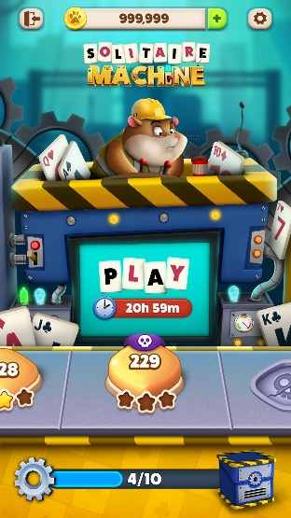

HEADER

CTA Button

**Halloween Live Ops Events:**

For the holiday we are planning to have the following Events:

1. Collectors – player needs to collect items to win rewards. The Items can be collected by playing the game and receiving surprise cards with the item. The duration of each collector is 1 day only.
   1. Come up with 2 collectors for Halloween and create the announcement to invite players to participate in the event.
   2. Write a push message for each of the items for IOS and Android users

HEADER

CTA Button

Android example: IOS example:

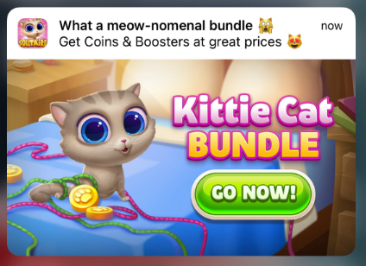

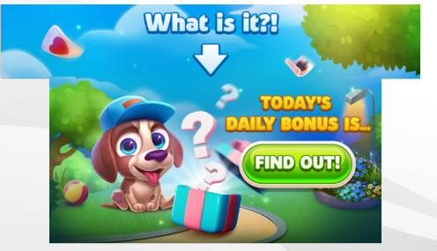

Examples for Live ops events:

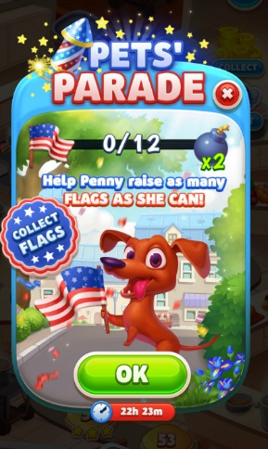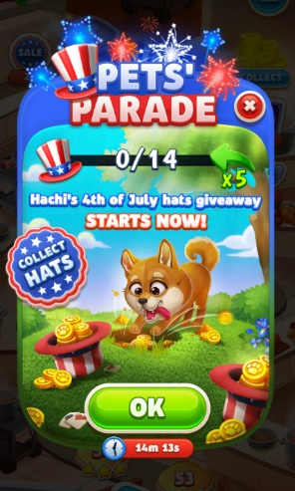

Live Ops event example:

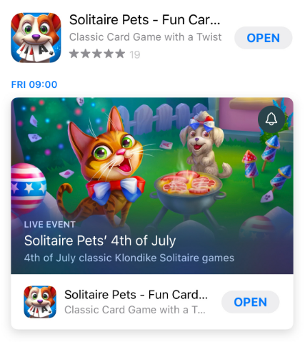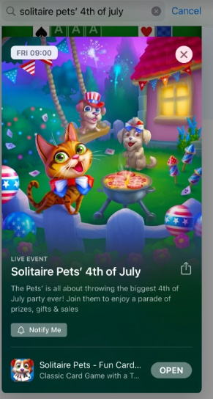

Guidelines:

* Name - 30 characters.
* Short description - 50 characters - Use these key words: solitaire, games, classic, Klondike
* Long description - 120 characters.

1. Facebook post – write a Facebook post congratulating them for the holiday with a free gift.